Online supplement

Participants
Exclusion criteria were a) ongoing intoxication (e.g. due to alcohol or other drugs), b) low cognitive capacity, c) other serious psychiatric comorbidity (ongoing psychotic symptoms or ongoing manic episode, suicidal ideation).

Measures
Secondary outcome measures included the PTSD Symptom Checklist for DSM-5 (PCL-5) [1], a self-report measure assessing the 20 DSM-5 symptoms of PTSD. The participants also filled in an intrusion diary, which assesses the daily number of intrusive memories of the traumatic event from day one to the last session. This intrusion diary has been used in previous early intervention studies [2, 3] and was translated into Swedish by the first author.
Depressive symptoms were assessed using the Montgomery Åsberg Depression Rating Scale–Self rated version (MADRS-S) [4]. General functioning was assessed using the World Health Organization Disability Assessment Schedule-12 (WHODAS) [5] and quality of life using the EQ-5D (Euroqol-5D) [6]. Sleep quality was assessed using the Insomnia Severity Index (ISI) [7]. Participants who were unable to attend the follow-up assessments at the clinic were interviewed via telephone.
The frequency of adverse events was assessed at session two and three of the intervention and at two and six months follow up using a structured interview. To control for possible expectation and non-specific factors between the PE and control group, we used the Treatment Credibility Scale [8] at session 1.

Interventions
Prolonged exposure (PE)
Prolonged exposure (PE) is based on the emotional processing theory developed by Foa and Kozak [9]. This theoretical framework posits that PTSD symptoms reflect pathological fear structures that do not accurately represent reality and are seen as signs that the trauma memory has not been sufficiently emotionally processed. This theory stipulates that in order to achieve emotional processing of the trauma memories, the patient needs to repeatedly activate the fear structure and access corrective information about the trauma memory. A failure in emotional processing is conceptualised to occur due to avoidance of the memory itself and its associated feelings, thoughts, and situations related to the trauma, which limits the activation of the fear structure and access to corrective information. These avoidance behaviors are thought to maintain the individuals’ erroneous negative perceptions about themselves and the world. PE aims to inhibit avoidance patterns by gradually approaching the trauma-related stimuli. Approaching the trauma-related stimuli is hypothesized to activate the fear structure and subsequently provide corrective information about the feared consequences of trauma. The adapted PE treatment used in this study has the same basic aim as traditional PE for PTSD with the difference that this early intervention has the potential to more swiftly modify the consolidation of the fear memory from the traumatic event [10].
In the first session, the participant was first given a brief rationale of the modified PE protocol and the function of avoidance behaviors to trauma memories. The rationale was followed by imaginal exposure, in which the participant was instructed to re-activate the trauma memory (i.e., visualize the event in their mind’s eye) for 20-30 minutes by recounting the traumatic event, talking in the present tense and repeat the memory if necessary to reach the time limit. Subjective units of distress were assessed regularly during each imaginal exposure. After the imaginal exposure, Socratic questions were used to address erroneous trauma-related cognitions. The imaginal exposure was recorded on a voice recorder and the participant was instructed to listen to the session on a daily basis in order to achieve emotional processing of the trauma memory.
In addition to imaginal exposure, the participant also received psychoeducation about common reactions after trauma and the importance of breaking avoidance patterns of situations that trigger trauma memories. Exposure in vivo was carried out through a home-work assignment. The participant also received basic skills in a breathing retraining technique. Session two and three followed the same format with continued imaginal and in vivo exposure. The intervention ended at session three with a summary of what the participant had learned from the sessions. All sessions were 60 minutes long and were conducted on a weekly basis.

Study progression
The flow of participants is shown in Figure S1. 292 trauma patients were screened using the digital screening record and 32 participants were included in the study. The most common reasons for exclusion was not meeting eligibility criterium A (n=71), not being able to contact the patient (n=41) and that more than 72 hours had passed since the traumatic event (n=38). Twenty-five participants had experienced an accident and 7 were victims of assault. On average 35 hours had passed from the trauma to the intervention. All but one of the participants had slept before the intervention.

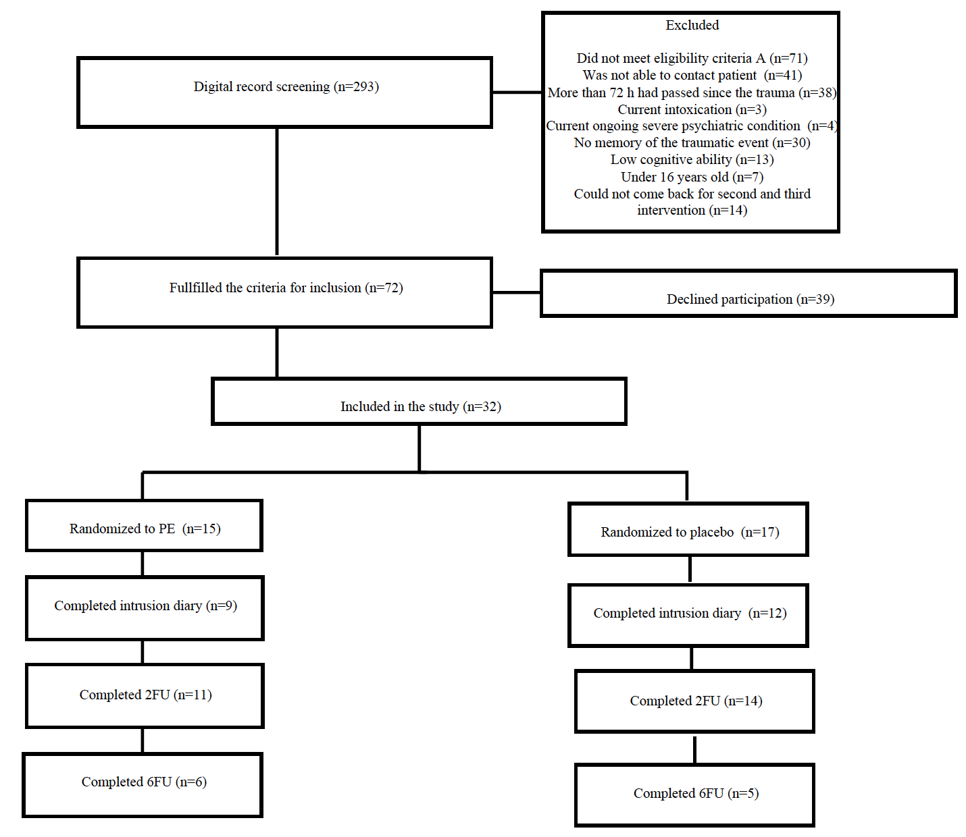
Figure S1. Participant flow chart.

We found gender difference between included participants (12 men and 20 women) and patients who were eligible but declined participation (31 men and 8 women). Younger people were also more likely to decline participation in the study: included patients had a mean age of 42 years and patients who declined participation were on average 32 years old.
Figure S2 shows how recruitment rate decreased rapidly to only 2.8% in the subsequent months of the organizational changes.
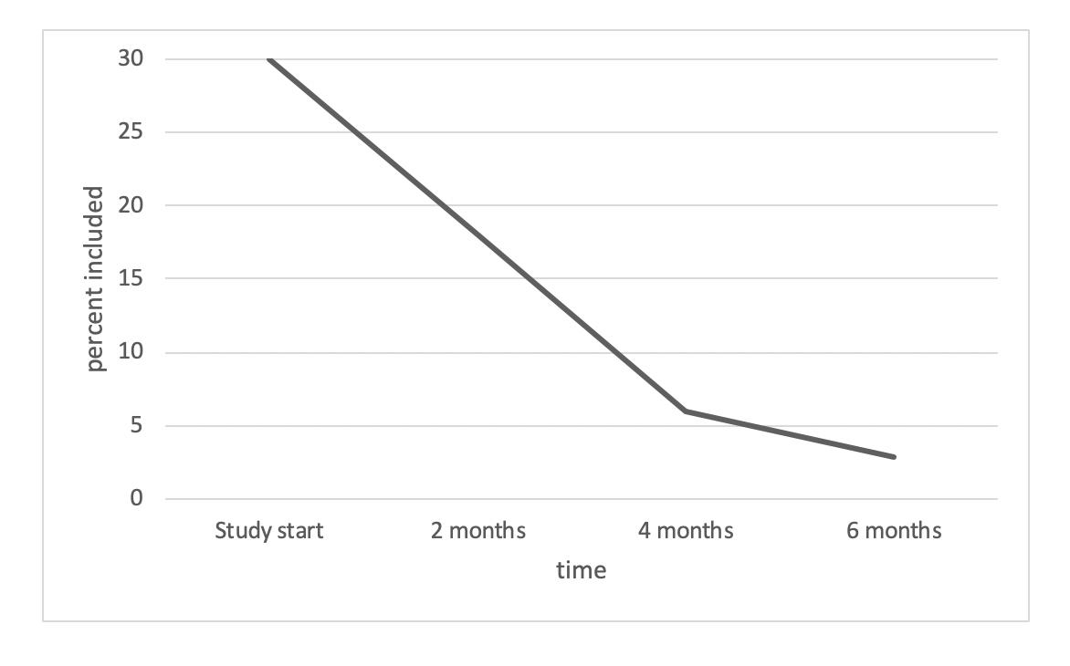
Figure S2. Recruitment rate of patients attending the emergency department during the study period.

Preliminary outcome data
Scores on the Treatment Credibility Scale were overall high in both conditions (M_{PE} = 41.2, M_{control} = 37.5). Four participants, two from each condition, dropped out of treatment. One participant perceived that being randomized to the control condition was negative and declined further participation. The other participant in the control condition did not give a reason for leaving the study. One participant in the PE group left the study due to perceiving the intervention as too emotionally demanding. The other participant in the PE group stated not being in need for the intervention as reason for drop out.
At follow-up, 25 of the 32 enrolled participants (78%) completed the CAPS-5 assessment at the 2-months follow-up and 11 (34%) at the 6-months follow-up. Seven of the 25 assessments (28%) at the 2-months follow-up were conducted by telephone. Nine (60%) participants in the PE group completed the intrusion diary between sessions 1 and 2, and 7 (47%) completed it between sessions 2 and 3. The corresponding figure for the control condition was 12 (70%) between session 1 and session 2 and 9 (53%) between sessions 2 and 3. SUD-ratings collected during the imaginal part of the PE sessions were available from 13 (86%) participants.
The mean number of intrusive memories are shown in Figure S3. The mean number of daily intrusions between session 1 and 2 was 4.68 in the PE group and 4.68 in the control condition. Between session 2 and 3, the mean number of daily intrusions was 0.19 in the PE group and 2.54 in the control condition.

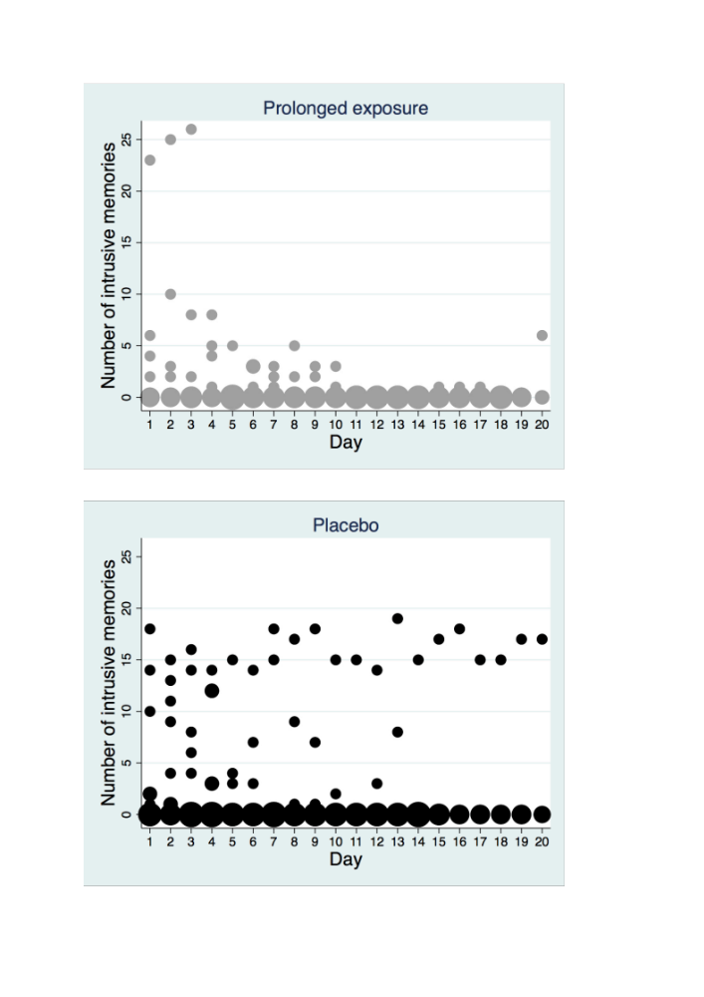

Figure S3. Frequency scatter graphs of the number of intrusive memories per day recorded in the intrusion diary during the intervention period for patients that returned the diary in each condition. The circle size illustrates number of participants who reported the indicated number of intrusive memories for each day.

1. Blevins, C.A., et al., The Posttraumatic Stress Disorder Checklist for DSM-5 (PCL-5): Development and Initial Psychometric Evaluation. J Trauma Stress, 2015. 28(6): p. 489-98.
2. Iyadurai, L., et al., Preventing intrusive memories after trauma via a brief intervention involving Tetris computer game play in the emergency department: a proof-of-concept randomized controlled trial. Mol Psychiatry, 2018. 23(3): p. 674-682.
3. Horsch, A., et al., Reducing intrusive traumatic memories after emergency caesarean section: A proof-of-principle randomized controlled study. Behav Res Ther, 2017. 94: p. 36-47.
4. Svanborg, P. and M. Asberg, A new self-rating scale for depression and anxiety states based on the Comprehensive Psychopathological Rating Scale. Acta Psychiatr Scand, 1994. 89(1): p. 21-8.
5. Üstün, T.B., et al., Measuring health and disability: Manual for WHO disability assessment schedule WHODAS 2.0. 2010: World Health Organization.
6. Rabin, R. and F.d. Charro, EQ-SD: a measure of health status from the EuroQol Group. Annals of Medicine, 2001. 33(5): p. 337-343.
7. Bastien, C.H., A. Vallieres, and C.M. Morin, Validation of the Insomnia Severity Index as an outcome measure for insomnia research. Sleep Med, 2001. 2(4): p. 297-307.
8. Borkovec, T.D. and S.D. Nau, Credibility of analogue therapy rationales. Journal of Behavior Therapy and Experimental Psychiatry, 1972. 3(4): p. 257-260.
9. Foa, E.B. and M.J. Kozak, Emotional processing of fear: exposure to corrective information. Psychol Bull, 1986. 99(1): p. 20-35.
10. McGaugh, J.L., Memory--a century of consolidation. Science, 2000. 287(5451): p. 248-51.

